LAB 8

1- Write a function POWER(m,n) that finds n^{th} power of the number m, without using Math.Pow() command.

Then call this function many times to find the result of the following formula.

1³ + 2³ + 3³ + 4³ + 5³ + 6³ + 7³ + 8³ + 9 + 10³

2- Write a function that calculates geometric mean of the n numbers in the array.
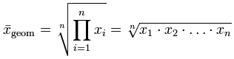

Examples:
int[] arr = {3,5,8,14}; int[] arr = { 45,42,43,48,41};
Output: 6.4 Output: 43.73

3- Write a function that finds the factorial of a number.

Write a function that finds Binomial Coefficient of two numbers: n and k. This function should call factorial function three times.

The Binomial Coefficient is
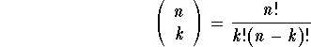

4- Write a program that calls a procedure to print the following shape using nested loops:

***
***
***
***
***

5- Write a function that converts given temperature in Fahrenheit (F) to Celsius (C).

Example:
Input: 100
Output: 37.77

6- Write a function that takes a number (between 100 and 999) from the user, and returns its tens digit.

Example:
Input: 179 Input: 496 Input: 715
Output: 7 Output: 9 Output: 1

